You are to find sites that exemplify the following color schemes:

* Monochromatic

Bird Malaysia

bird-malaysia.com/

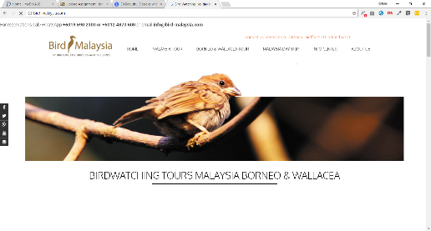

These colors are muted, and the use of black and white is dominate with the colors taking up a smaller percentage.

* Analogous

Bigtop

bigtop.jobs/jobs/



* Split Complimentary

Paper Tiger

<https://www.papertiger.com/>

The us of black and white is used to enforce the brightness of the split complementary colors.